**REI602M Quiz 29.1.2021**

Hand in on Gradescope before 22:00 on Jan. 30 (Saturday). Each question will be given 1, 0.5 or 0 points as follows. If the question is more or less correct it gets 1 point. If it is partly correct it gets 0.5, and if it is missing or completely wrong it gets 0 points.

1)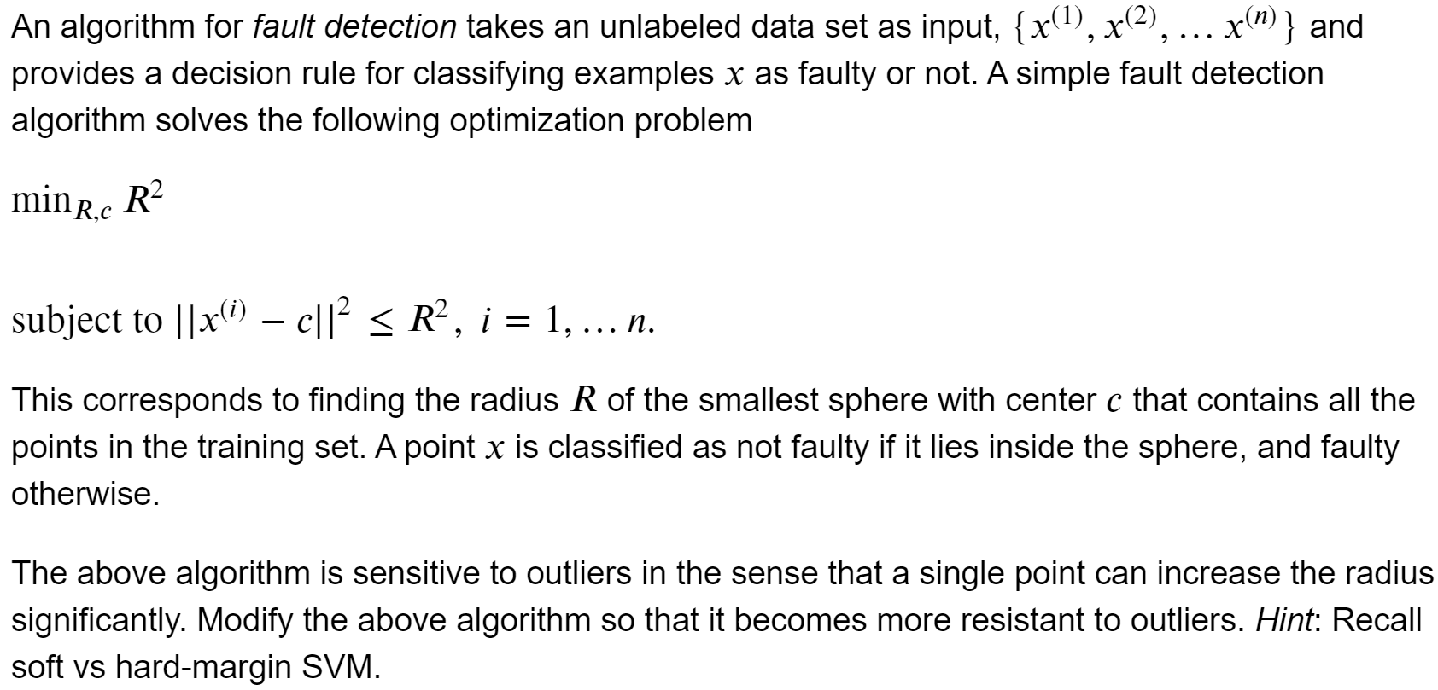

I would use the SVM with a Radial Basis Kernel.

$$\min_{R,c,γ}R^{2}$$

subject to $e^{-γ{||x^{(i)}-c||}^{2}} <= R^{2} , i = 1,....n.$

where $γ$ controls the decision boundary.

2)

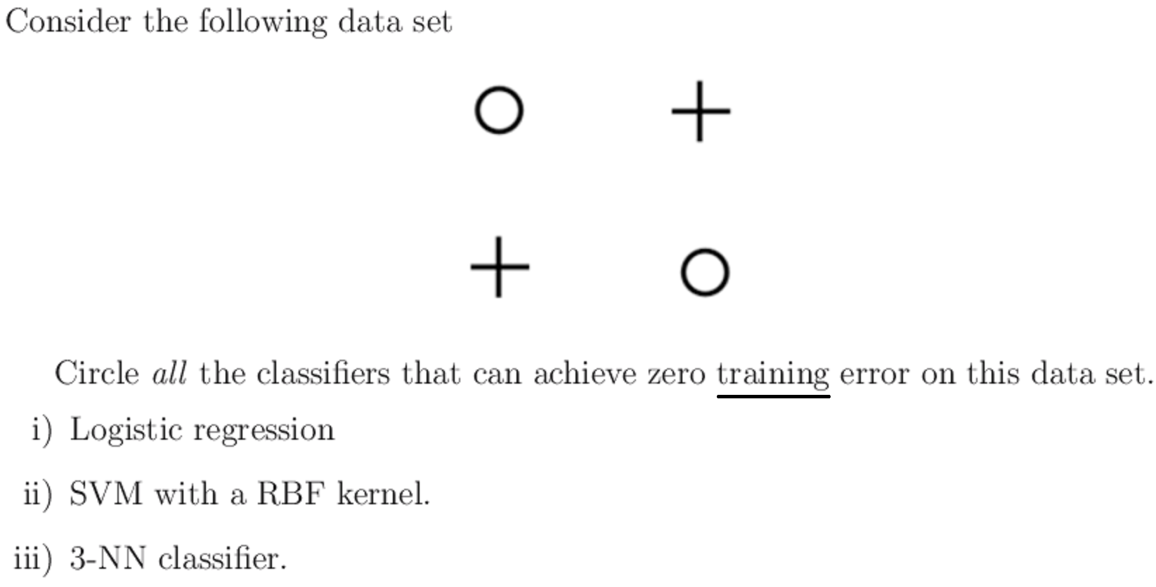

**only** SVM with a RBF kernel.